- Plz see below: supportive research papers for knee injections

Platelet-rich plasma versus hyaluronic acid in the treatment of knee osteoarthritis: a meta-analysis

https://josr-online.biomedcentral.com/articles/10.1186/s13018-020-01919-9#:~:text=A%20total%20of%2020%20RCTs,pain%20scores%20and%20VAS%20scores.

Efficacy of Platelet-Rich Plasma in the Treatment of Knee Osteoarthritis: A Meta-analysis of Randomized Controlled Trials

https://pubmed.ncbi.nlm.nih.gov/28012636/

Effect of Intra-articular Platelet-Rich Plasma vs Placebo Injection on Pain and Medial Tibial Cartilage Volume in Patients With Knee Osteoarthritis

https://jamanetwork.com/journals/jama/fullarticle/2786501

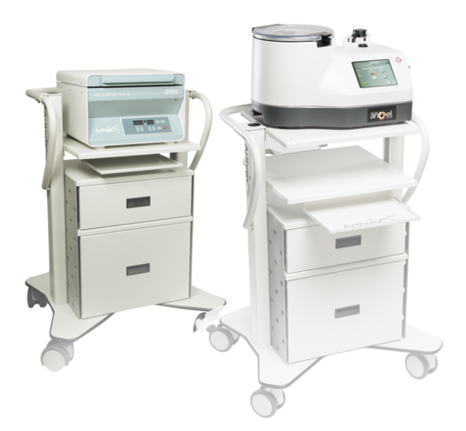

- Knee Injection: PRP

- The various types of injections that can help including cortisone, PRP and viscosupplimentation.

PRP Links:

- Efficacy of Platelet-Rich Plasma in the Treatment of Knee Osteoarthritis: A Meta-analysis of Randomized Controlled Trials

- Effectiveness of Platelet-Rich Plasma in the Treatment of Knee Osteoarthritis A Meta-analysis of Randomized Controlled Clinical Trials

- Platelet-Rich Plasma Versus Hyaluronic Acid for Knee OsteoarthritisA Systematic Review and Meta-analysis of Randomized Controlled Trials

- Platelet-rich plasma versus hyaluronic acid in the treatment of knee osteoarthritis A meta-analysis

- Treating Knee Osteoarthritis With Platelet-Rich Plasma and Hyaluronic Acid Combination Therapy

